Expt No:  02 | WATER LEVEL CONTROL SYSTEM
Date:
/ /2025

- AIM:
To design a ladder logic program to maintain the water level in a tank.
- APPARATUS REQUIRED:

- VPLCT - 01 [PLC Trainer kit].
- Water level indicator [Float switches - 2].
- Personal Computer [PC].
- VersaPro Software Installed.
- RS - 232 cable.
- Patch Chords.

- PROCEDURE:

- Load the Versapro Software to the PC.
- Open the Versapro Software.
- Switch ON the PLC Trainer and Water level System.
- Connect PLC and Water level System kit.
- Open the New folder and draw the ladder logic program.
- Connect the PLC to PC.
- Select the correct hardware Configuration [Sl. No].
- Store the Program to PLC.
- Run the Program.
- Verify the performance of the Water level System.

- PROBLEM STATEMENT:

Water Level controller is used to Fill/drain the tank, which is depends upon high/low level in tank water. If the tank is in low level the solenoid valve will open & motor starts - ON Position if the tank is in high level, the solenoid valve will be close & motor stop - OFF position.

- BLOCK DIAGRAM:

- PROCESS DIAGRAM:

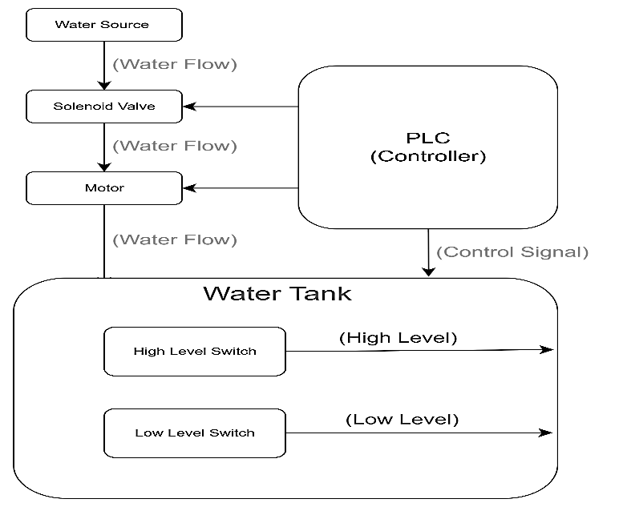

- WIRING DIAGRAM:

- LADDER DIAGRAM:

- RESULT:
Thus, the ladder logic program to maintain the water level in a tank has been designed and tested using the water level kit.

